Business plan Hakutaku

1- Introduction: 2
2- What is Hakutaku: 2
3- Business Description 3
4- Culture: 5
5- Vision: 5
6- Problem Addressed: 5
7- Product: 6
8- Go to market: 8
9- Market and Competition: 8
10 - Financial Plan 11
Timeline: 12
Return: 12
Exit: 14

1- Introduction:
This material aims to present our business plan, the assets we have already built, and a clear outlook for the company’s next year.
We want to show, with full transparency, where we are, what we already have in hand, and, most importantly, what is still under construction.
We believe that building a strong business plan is not only about promises, but also about clarity on where we can truly generate impact. For that reason, we highlight not only our progress, but also the gaps and challenges we intend to address.

2- What is Hakutaku:
Hakutaku is a B2B SaaS for knowledge management for companies. In practice, we are a conversational agent that consumes all the data and knowledge sources a company has and delivers this information in an intuitive way to employees, according to the difficulties they may face in their day-to-day work.
Who we are:
Hakutaku was founded and is run by three university students in their final year at Inteli (Instituto de tecnologia e liderança).
Raduan Muarrek is the CEO and has prior experience as a consultant at NeoStrategy Consulting, an automation developer at BTG, in venture capital and data at Anjos do Brasil, and he founded and chaired Inteli’s entrepreneurship league.
Why he is at Hakutaku: To build a name and earn reputation and access to capital to create future ventures that help the city of São Paulo.
Patrick Miranda is the COO and has prior experience as a full-stack developer at BTG Pactual.
Why he is at Hakutaku: Strong family inspiration (his father has always been an entrepreneur). He also believes entrepreneurship is the best path to financial freedom, and that he is at an excellent point in his life to make this move.
Vinicios Lugli is the CTO. He has always programmed in low-level languages, but since last year he has wanted to learn about GenAI, seeing Hakutaku as an interesting project to become an expert in it.
Why he is at Hakutaku: He enjoys programming in Rust and building great products.

3- Business Description
Going into more detail about Hakutaku, the company was officially registered in November 2024, although it had already been operating and developing the product since September of the same year, the month in which all members left their respective jobs to focus 100% on the solution.
Our initial cash position was built entirely from hackathons, which enabled an initial cash amount of BRL 15,000 for the company. This amount, together with a few additional one-off contributions from the partners to pay for legal and design services for the solution, totals about BRL 22,000 invested from the partners’ own pockets so far, in addition to a pre-seed round carried out in 2025, the terms of which we cannot disclose.
It is also worth mentioning that the company has $1,000 in credits from Microsoft for Startups and $5,000 on AWS to support the development of the solution.

Regarding the tax regime, we are subject to the rules of the city and state of São Paulo. Key details include:
Tax regime: Simples Nacional
CNAE of the provided service: 6202-3/00 - Desenvolvimento e licenciamento de programas de computador customizáveis
Tax rate: 6% (requiring 27% of the invoice amount as pro-labore to maintain this rate)
Regarding the current ownership structure, it is worth noting that the company is registered as an Ltda with 100% of the quotas held by the founding partners or qualified investors. The founders are:
[Figure 1: Hakutaku Partners]
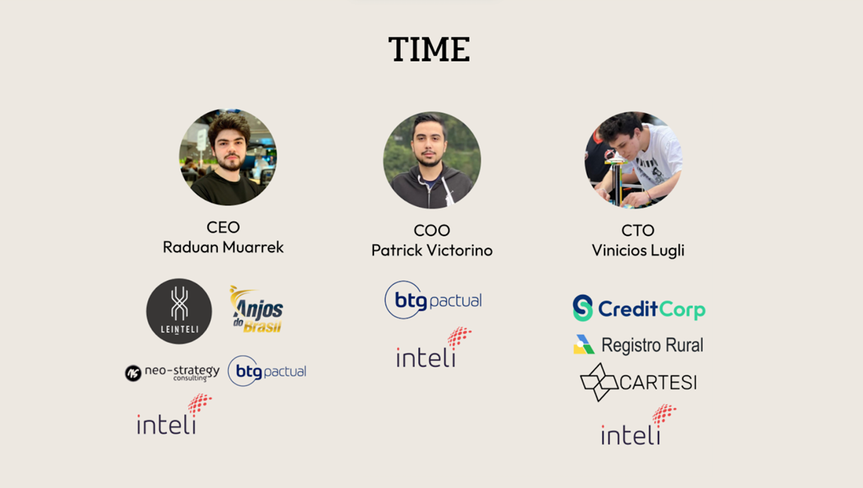
Source: Prepared by the authors, 2025.

● Partner 1:
○ Name: Raduan Muarrek
○ Role: CEO
○ linkedin: https://www.linkedin.com/in/raduanmuarrek/
● Partner 2:
○ Name: Patrick Victorino Miranda
○ Role: COO
○ linkedin: https://www.linkedin.com/in/patrick-miranda/
● Partner 3:
○ Name: Vinicios Lugli
○ Role: CTO
○ linkedin: https://www.linkedin.com/in/vinicioslugli/
○ github: https://github.com/ViniciosLugli/ViniciosLugli

The combination of a technical team, a well-defined ownership structure, and an optimized tax regime allows Hakutaku to operate with agility and focus on developing a solid product aligned with current market demands in technology and data.

4- Culture:
Friendship -> We care about each other, and we care that Hakutaku plays a positive role in the partners’ lives.
Authenticity and originality -> The three partners have an authentic style. We have an environment where everyone can express themselves without much judgment from others. This is reflected in the product, where we can share ideas and propose improvements freely.
Innovation and Guerrilla -> Trying to generate results with little and "making it work" to achieve it. Evidence of this is our initial funding coming from hackathon wins.

5- Vision:
To be the leading knowledge management SaaS in Latin America.

6- Problem Addressed:
While 20% of teams waste time looking for information that already exists, only 3% of companies use AI for knowledge management. We work in a way that uses GenAI to consume and use everything a company has, effectively addressing the problem. This validation is also supported by interest from large companies (such as Bemobi and Stark Bank), where we validated the solution during development, and also with smaller companies where we have already signed contracts.
Even though this problem exists, companies struggle to implement strong knowledge management because this type of solution is mostly offered by foreign startups, which end up being extremely expensive and do not have solutions and support adapted to the Brazilian market. Examples include Pareto, Notion, and ClickUp, which, because they are plug-and-play, cannot really understand the difficulties and peculiarities of Brazilian companies.
In summary, we work on three premises:
- We organize data and documentation that is scattered across different software and databases.
- We enable Brazilian companies to have a knowledge management software that is more affordable, with lower minimum requirements and a service layer that can understand the complexity of Brazilian companies.
- Support and onboarding adapted to Brazilian culture.

7- Product:
Our product has four major environments, in order of importance:

I - Chat interface -> Main screen, where the user actually asks Hakutaku a question.
With add-ons -> prompt suggestions and a list of previous chats.
[Figure 2: Hakutaku chat screen]
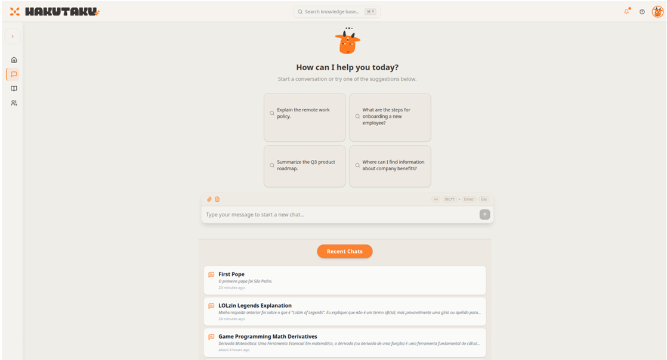
Source: Prepared by the authors, 2025.
II - Admin area -> Features include: missing data, document access, and productivity gain insights.
[Figure 3: Hakutaku admin screen]
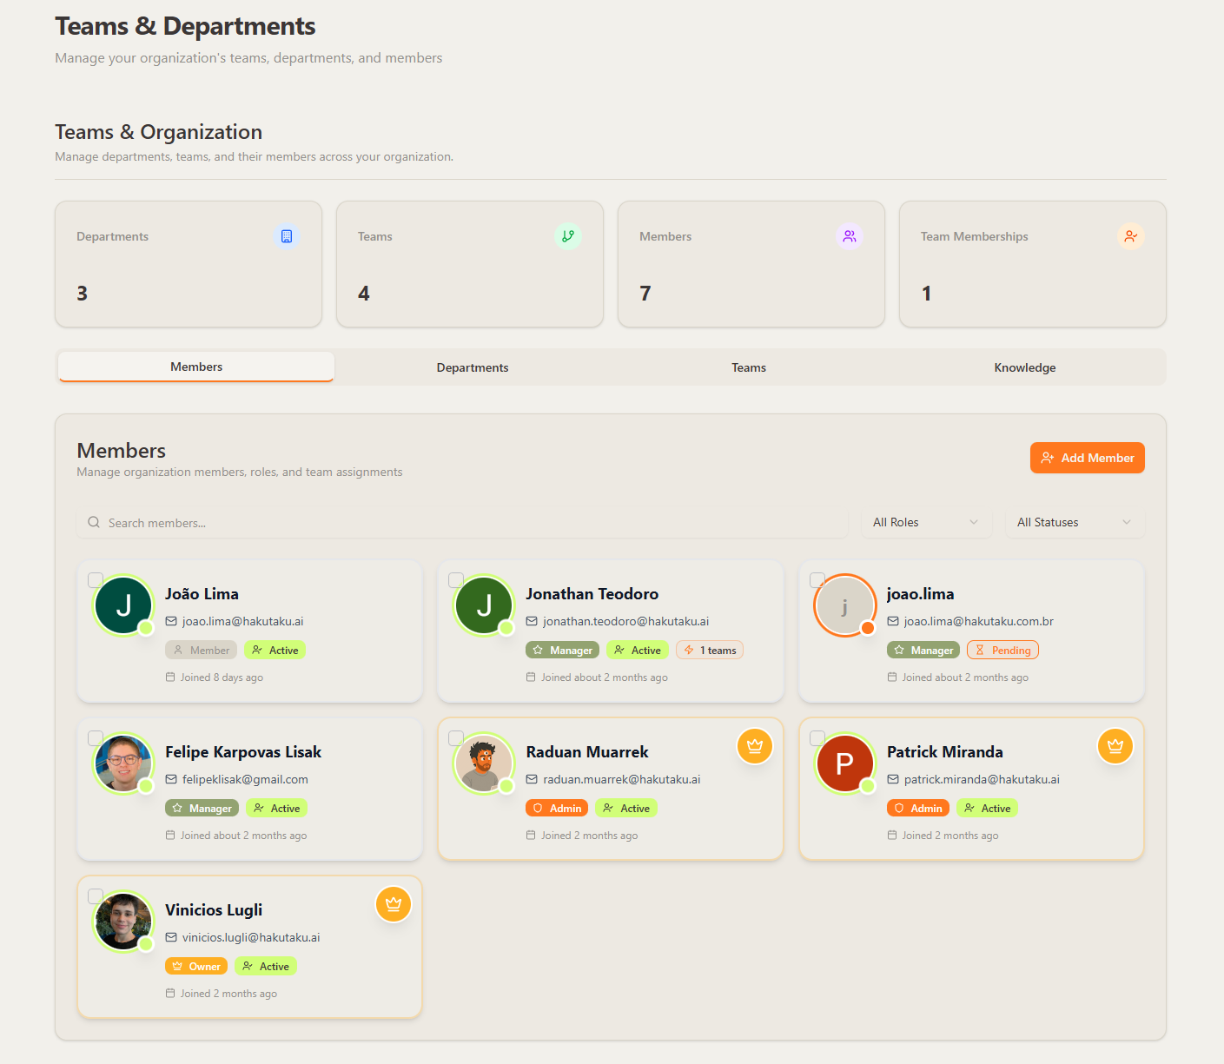
Source: Prepared by the authors, 2025.
III - Knowledge hub -> Standardizes the data source into a single environment.
[Figure 4: Hakutaku knowledge hub screen]
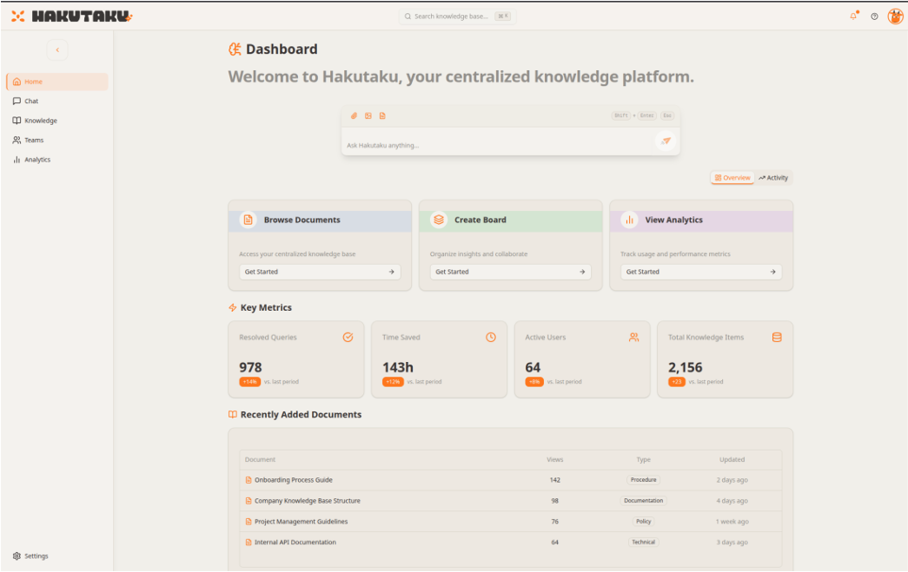
Source: Prepared by the authors, 2025.

IV - Board (On Hold) -> Creation of a "sandbox" board for each user, where they can create chats, have better visibility into important data, and share boards with other employees. Development is frozen due to prioritization of more important features for MVP development.

8- Go to market:
Because we have a technical product-profile team, we do not yet have a well-defined go-to-market strategy. The objective for the next months is precisely to build something more solid in this regard. However, we have some premises that will guide the strategy that will be created in the next months, as mentioned in the timeline.
Short term:
- Integrations tailored to each client’s needs
- Service layer as a differentiator
Medium term:
- Guerrilla marketing appeal using the distinct branding we have built
Long term:
- Community marketing: showing how to build Hakutaku inside your company

9- Market and Competition:
For market sizing, we calculated using a bottom-up approach:
- TAM: BRL 86.8 billion - considering 401,720 companies in Brazil with more than 50 employees, average annual ticket of BRL 1,200 (401,720 x 180 x 1,200)
- SAM: mid-sized and large companies with higher digital maturity - estimated at BRL 8 billion
- SOM: initial operation in São Paulo (SP), focusing on customers with profile and readiness for dark start, estimated at BRL 500 million
This market tends to grow rapidly, driven by global trends: it is expected that by 2025 more than 80% of companies will use AI in their operations, and the global market for enterprise search and AI-based knowledge management already exceeds USD 43.8 billion (CAGR of 37.6% through 2030).
Today we have a market without many competitors, but it is forming into a red ocean for the coming years. This is driven by the large market and by a thesis already validated abroad for years, and by the fact that the ease of using GenAI has lowered barriers worldwide. The biggest global case is Glean, a company that is already a unicorn in the US and operated before the global AI trend.
Main competitors:
- Sana AI (International): AI knowledge management/LMS platform with personalization, praised for user-friendly interface and automatic recommendations, but with limited integrations and a focus on training rather than internal corporate knowledge management.
- Lookbox (International): corporate search and knowledge base tool, high cost, less focus on conversational AI, main focus on Business Intelligence.
- Nama (Brazil): started building agents for knowledge management, like Hakutaku. We have limited information since they pivoted into the same activity as us.
- Glean: leading knowledge management player abroad. Focuses on enterprise customers with high-ticket contracts and ends up being unfeasible for companies here.
[Figure 5: Competitors]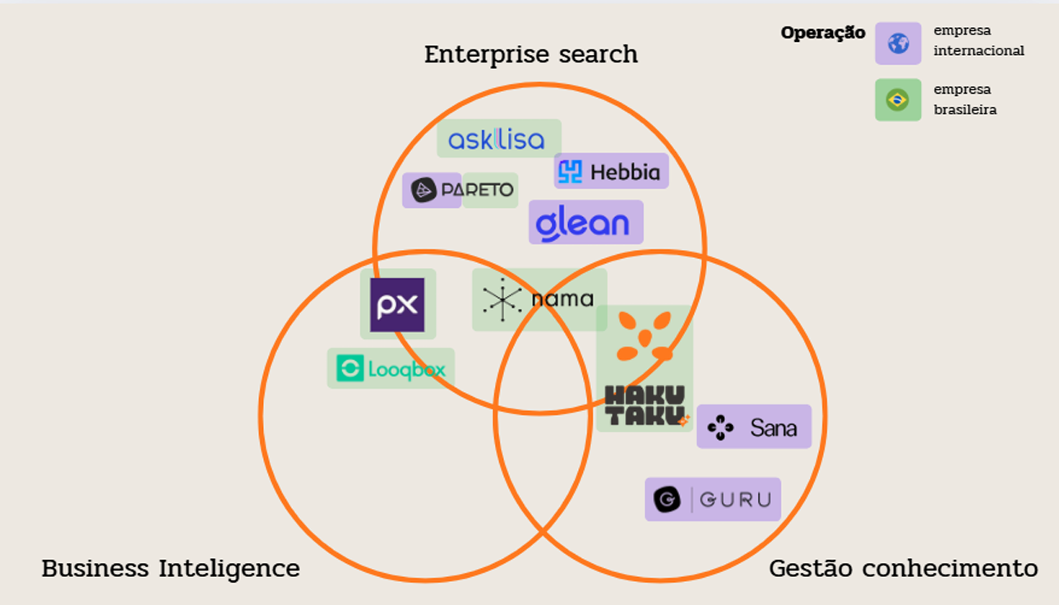Source: Prepared by the authors, 2025.
Today we do not have something that effectively differentiates us from these players, but our plan is:
- A strong local service layer, with support adapted to the Brazilian context. This protects us if a company like Glean wants to enter Brazil.
- Exclusive focus on internal knowledge management (not customer support and not dashboards), with the goal of strengthening and expanding the knowledge base of Brazilian companies.
There was already an interesting movement abroad around knowledge management, and as entry barriers decreased, more companies began to operate in the sector. With the technology we built and a technical team, we can both compete in this space and also niche down for a specific audience or use case. We have the following features mapped:
1. Features in development or already available
- Memory: allows Hakutaku to remember previous interactions to avoid repeating information and increase user retention (NPS).
- Prompt Library: users can create, search, and reuse ready-made prompts to facilitate interaction with the tool.
- Show sources for answers: adds reliability to returned content, increasing perceived safety.
- Hallucination Hunter: helps identify and avoid incorrect answers, improving answer precision.
- Knowledge Graph: allows organizing and connecting information to increase Hakutaku’s ability to find the right data.
These features aim to solve problems such as:
- Lack of using prior context
- User difficulty in knowing what to ask
- Insecurity about the truthfulness of the answer
- Failures to find the correct information
2. Board-related features (collaboration and context)
- Save and send information to the "buddy": facilitates sharing insights.
- Make boards accessible by role: organize and segment knowledge.
- Create public guides (example: API guide): promotes sharing best practices.
- Edit together with the "buddy": adds a real-time collaboration component.
- Share context across chats: allows continuity of conversations at different times or with different team members.
- Chart generation and real-time updates: focused on monitoring metrics and improving the experience.
These functionalities increase NPS, reduce the number of prompts until the ideal result, and improve Hakutaku’s internal reference.
3. Future features (ideation and innovation)
- Agent creation tool: with upload and selection of agents to automate specific tasks.
- Meeting recording and minutes generation: automatic record for efficient documentation.
- Creation of chatbots based on specific connections: exportable and designed for recurring usage.
- Answering questions outside the base: via a "Who knows the answer?" feature and integration with tools like Intern bit.ly.
These ideas aim to reduce documentation time, increase productivity, reduce repetitive flows, and deal with data gaps ("missing data").
Regardless of features, our objective is to help employees be more productive and focus on what they were hired to do, instead of spending time searching for information. So, even though mapped, this is not yet a roadmap, and we will prioritize the usability requested by our first customers.

10 - Financial Plan

Note:

Due to contractual matters and sensitive information, items such as employee costs, development, and marketing cannot be included in this document. In addition, any information about investments and the company’s current cash position also had to be hidden.

Timeline:
To ensure sustainable growth and validate Hakutaku’s business model, we prepared a strategic timeline divided into monthly milestones. This plan covers the company’s next 12 months.
Below is the breakdown of the planned stages:
Period | Objectives and Strategic Actions:

Month 1-2: Finalize solution validation, final product adjustments, first revenue-generation tests, and structuring the cost base.
Month 3: Create the sales function and hire the technical team (devs) to accelerate platform development.
Months 4-6: Expand the customer base with focus on creating strategic connections and robust integrations with external systems.
Months 7-11: Begin approaching the enterprise segment, close the first contract of this type, and expand the technical team (addition of a mid-level developer).
Month 12: Consolidate the active customer base and reach operational break-even.

Return:
Hakutaku’s revenue projection was built based on a monthly licensing model per customer, with an initial focus on small and mid-sized companies and later entry into the enterprise segment.
Below is the expected return on investment over the first year, with the main project milestones:

Month | Customers | Avg. no. of licenses | MRR | Costs | Taxes | Net | Notes
1 | 3 | 10 | R$ 2.997,00 | R$ 599,40 | R$ 299,70 | R$ 2.097,90
2 | 3 | 10 | R$ 2.997,00 | R$ 599,40 | R$ 299,70 | R$ 2.097,90
3 | 4 | 15 | R$ 5.994,00 | R$ 1.198,80 | R$ 599,40 | R$ 4.195,80
4 | 4 | 15 | R$ 5.994,00 | R$ 1.198,80 | R$ 599,40 | R$ 4.195,80
5 | 5 | 15 | R$ 7.492,50 | R$ 1.498,50 | R$ 749,25 | R$ 5.244,75
6 | 6 | 15 | R$ 8.991,00 | R$ 1.798,20 | R$ 899,10 | R$ 6.293,70
7 | 8 | 20 | R$ 15.984,00 | R$ 3.196,80 | R$ 1.598,40 | R$ 11.188,80 | Start enterprise strategy
8 | 10 | 20 | R$ 19.980,00 | R$ 3.996,00 | R$ 1.998,00 | R$ 13.986,00 | Consolidate sales strategy
9 | 14 | 20 | R$ 27.972,00 | R$ 5.594,40 | R$ 2.797,20 | R$ 19.580,40
10 | 18 | 20 | R$ 35.964,00 | R$ 7.192,80 | R$ 3.596,40 | R$ 25.174,80 | Close with 1 large enterprise
11 | 20 | 35 | R$ 69.930,00 | R$ 13.986,00 | R$ 6.993,00 | R$ 48.951,00 | Increase average number of licenses
12 | 25 | 50 | R$ 124.875,00 | R$ 24.975,00 | R$ 12.487,50 | R$ 87.412,50

As a central assumption of this financial projection, we consider a variable cost structure equivalent to 20% of gross revenue, which ensures an operating margin of 80% for Hakutaku. Taxes were estimated at 10% over gross value, resulting in a net margin of approximately 70% over the projected period.
Another relevant point is that Hakutaku’s business model is based on selling monthly licenses at a unit price of R$ 99,90, with an initial focus on small and mid-sized companies. Starting in month 7, we begin a market penetration strategy for the enterprise market, which includes a higher volume of licenses per client and higher average contract value.

Exit:
Potential exits are welcome as long as they fulfill each partner’s objective specified at the beginning of this document. Through the strategy of a service layer and the creation of a customer base that is difficult to penetrate due to the complexity of understanding it, we believe Hakutaku is a strong acquisition for any foreign company that wants to start operating in Latin America.

